

**Data Analyst Project**

**Data Columns Name :**

|  |
| --- |
| **Order_ID** |
| **Customer_ID** |
| **Product_ID** |
| **Product_Name** |
| **Category** |
| **Price** |
| **Quantity** |
| **Total_Amount** |
| **Order_Date** |
| **Delivery_Date** |
| **Order_Status** |
| **Payment_Method** |
| **City** |
| **Occasion** |
| **Delivery_Time_Minutes** |
| **Customer_Age** |
| **Delivery_Type** |
| **Discount_Applied** |

**SQL Questions and Answer :**

**1. Retrieve All Successful Orders**

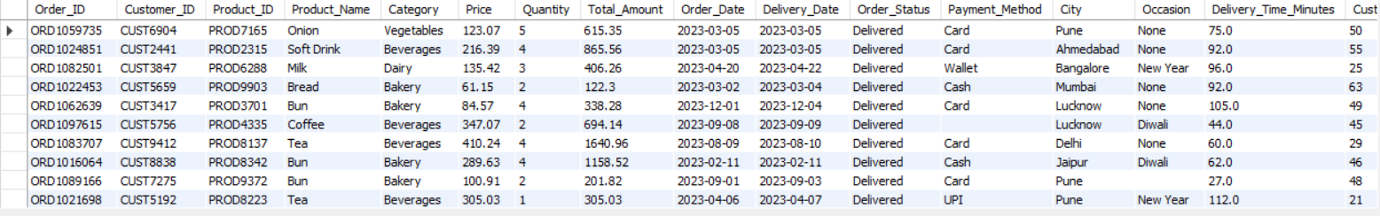select * from blinkit_grocery_data where order_status = 'Delivered';

**2. Find the Average Delivery Time per City**

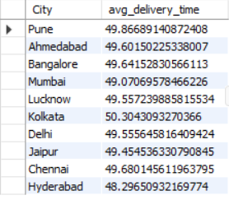select City , avg(Delivery_Time_Minutes) As avg_delivery_time from blinkit_grocery_data group by City;

**3. Get the Total Number of Cancelled Orders by Customers**

select count(*) from blinkit_grocery_data where order_status='Cancelled';

**4. List the Top 5 Customers Who Placed the Highest Number of Orders**

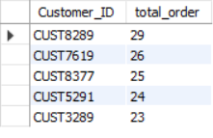select Customer_ID , count(Product_ID) as total_order from blinkit_grocery_data group by Customer_ID order by total_order DESC limit 5;

**5. Identify the most popular products by total quantity sold**

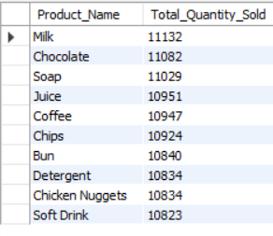select Product_Name, SUM(Quantity) as Total_Quantity_Sold from blinkit_grocery_data group by Product_Name order by Total_Quantity_Sold DESC limit 10;

**6. Find the Best and Worst Performing Product Categories**

--- Best Performing (Highest Sales) ---

select Category , sum(Total_Amount) as total_sales from blinkit_grocery_data group by Category order by total_sales DESC

--- Worst Performing (Lowest Sales) ---

select Category, sum(Total_Amount) as total_sales from blinkit_grocery_data group by Category order by total_sales ASC

**7. Retrieve All Orders Paid via UPI**

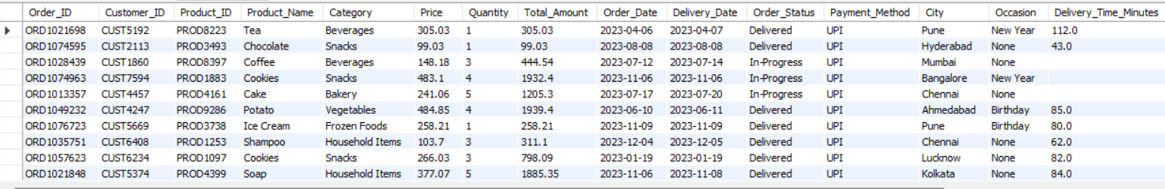select * from blinkit_grocery_data where Payment_Method = 'UPI';

**8. Calculate the Total Number of Orders with Discounts Applied**

select COUNT(*) AS Total_Discounted_Orders from blinkit_grocery_data where Discount_Applied = 'TRUE';

**9. Find the Total Number of Orders Placed on Weekends**

select COUNT(*) as Weekend_Orders from BlinkIT_Grocery_Data where DAYOFWEEK(Order_Date) IN (1, 7);

**10. Calculate the Percentage of Express vs Standard Deliveries**

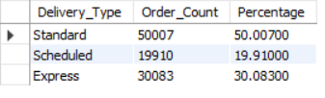select Delivery_Type ,count(*) as Order_Count, (count(*) * 100.0/ (select count(*) from blinkit_grocery_data)) as Percentage from blinkit_grocery_data group by Delivery_Type;

**11. Find the Total Revenue During Festival Occasions**

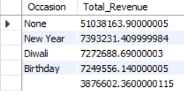select Occasion, SUM(Total_Amount) AS Total_Revenue from blinkit_grocery_data where Occasion IS NOT NULL group by Occasion order by Total_Revenue DESC;

**12. Find the Most Common Age Group of Customers**

select Customer_Age, COUNT(*) AS Order_Count from blinkit_grocery_data group by Customer_Age order by Order_Count DESC limit 1;

**Retrieve All Answers (View)**

create database Blinkit;

use blinkit;

SELECT * FROM blinkit.blinkit_grocery_data;

# 1. Retrieve All Successful Orders

select * from Delivered_Orders;

# 2. Find the Average Delivery Time per City

select * from delivery_time_for_each_city ;

# 3. Get the Total Number of Cancelled Orders by Customers

select * from cancelled_order_by_customers;

# 4. List the Top 5 Customers Who Placed the Highest Number of Orders

select * from Top_5_Customers;

# 5. Identify the most popular products by total quantity sold

select * from most_popular_product;

# 6. Find the Best and Worst Performing Product Categories

#Best Performing (Highest Sales):

select * from Best_product;

#Worst Performing (Lowest Sales):

select * from Worst_Product;

# 7. Retrieve All Orders Paid via UPI

select * from UPI_Payment;

# 8. Calculate the Total Number of Orders with Discounts Applied

select * from discount;

# 9. Find the Total Number of Orders Placed on Weekends

select * from Weekend_Demands;

# 10. Calculate the Percentage of Express vs Standard Deliveries

select * from delivery_for_express_vs_standard;

# 11. Find the Total Revenue During Festival Occasions

select * from Total_Revenue_During_Festival_Occasions ;

# 12. Find the Most Common Age Group of Customers

select * from Age_Group_Of_Customer;

**Same Thing In Excel :**

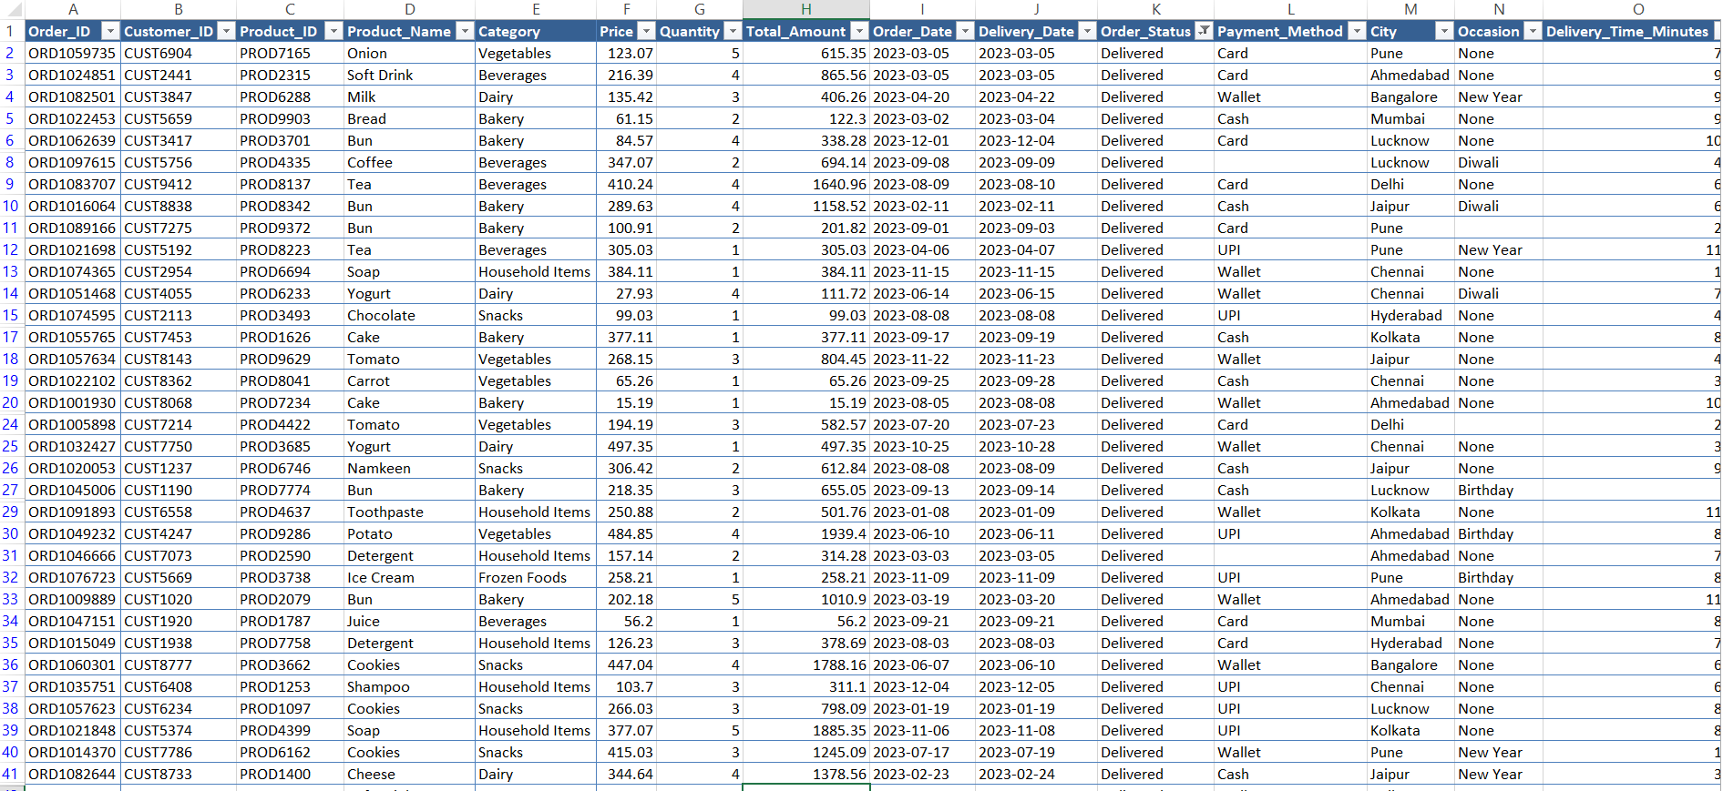1. Retrieve All Successful Orders

2. Find the Average Delivery Time per City

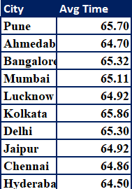 = AVERAGEIF(blinkit_grocery_data!M:M,Analyze!D4,blinkit_grocery_data!O:O)

3. Get the Total Number of Cancelled Orders by Customers

=COUNTIF(blinkit_grocery_data!K:K,"Cancelled")

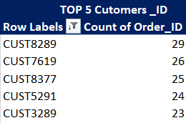 4. List the Top 5 Customers Who Placed the Highest Number of Orders (Used Pivot Table)

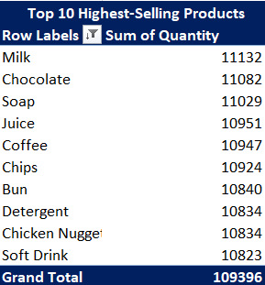5. Identify the most popular products by total quantity sold (Used Pivot Table)

6. Find the Best and Worst Performing Product Categories (Used Pivot Table)

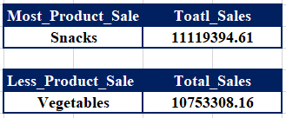 --- Best Performing (Highest Sales) ---

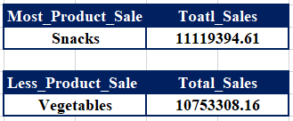 --- Worst Performing (Lowest Sales) ---

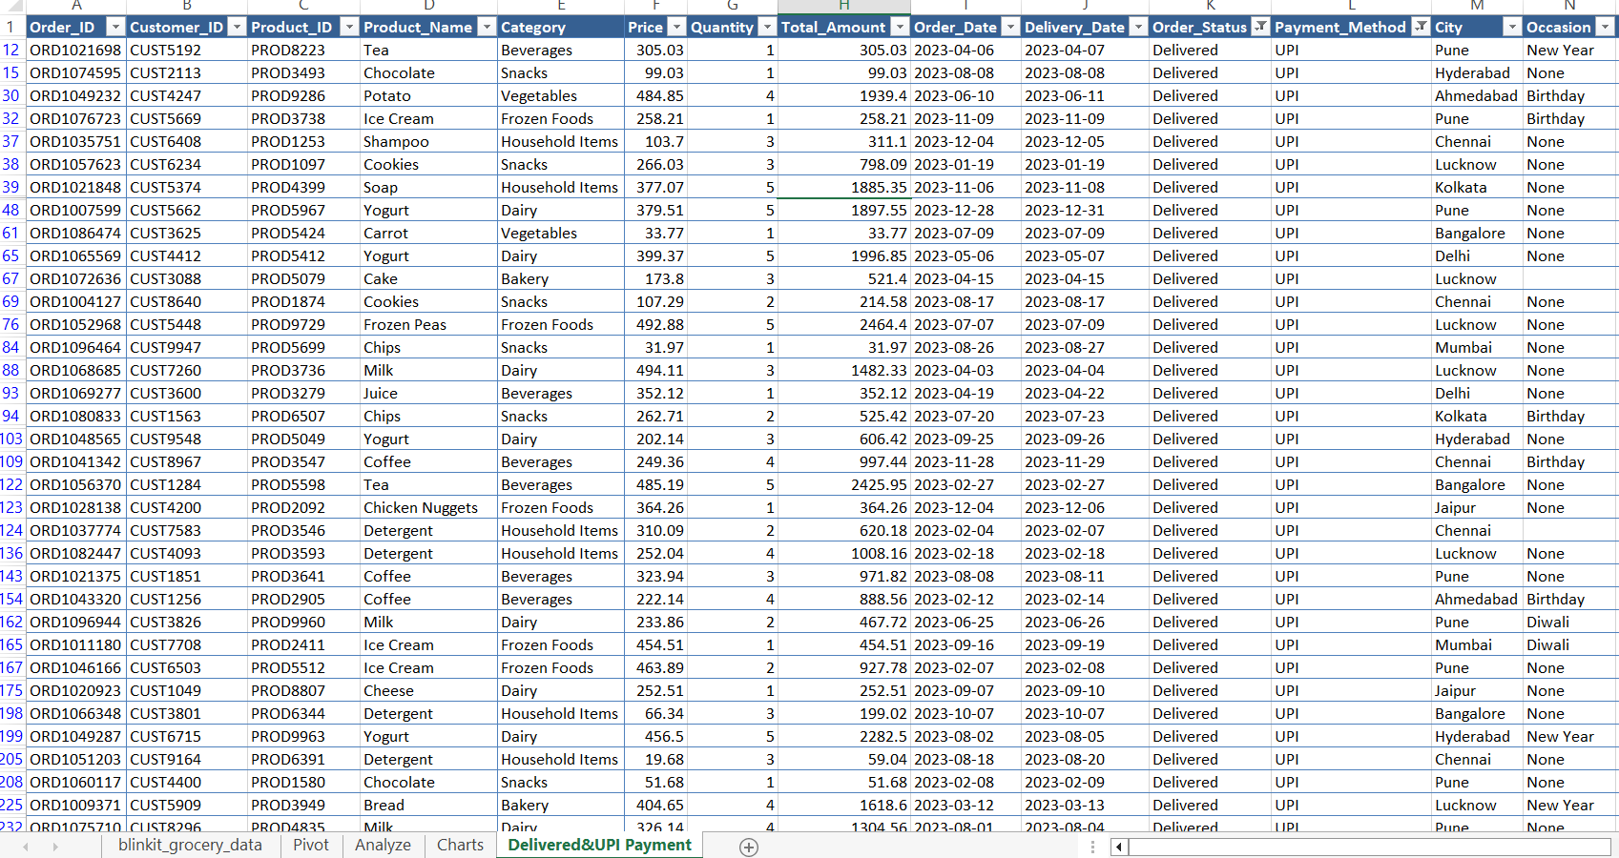7. Retrieve All Orders Paid via UPI (Used Filter)

8. Calculate the Total Number of Orders with Discounts Applied

=COUNTIF(blinkit_grocery_data!R:R,"True")

9. Find the Total Number of Orders Placed on Weekends

=TEXT(I:I,"dddd") (Also done with pivot table)

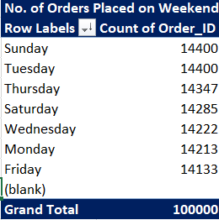

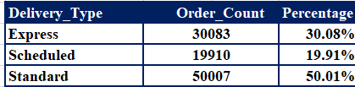10. Calculate the Percentage of Express vs Standard Deliveries (Using Pivot Table)

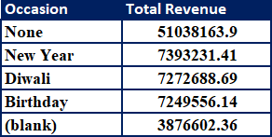11. Find the Total Revenue During Festival Occasions (Using Pivot Table)

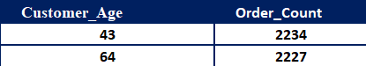12. Find the Most Common Age Group of Customers (Using Pivot Table)

* **Analysis Sheet:**

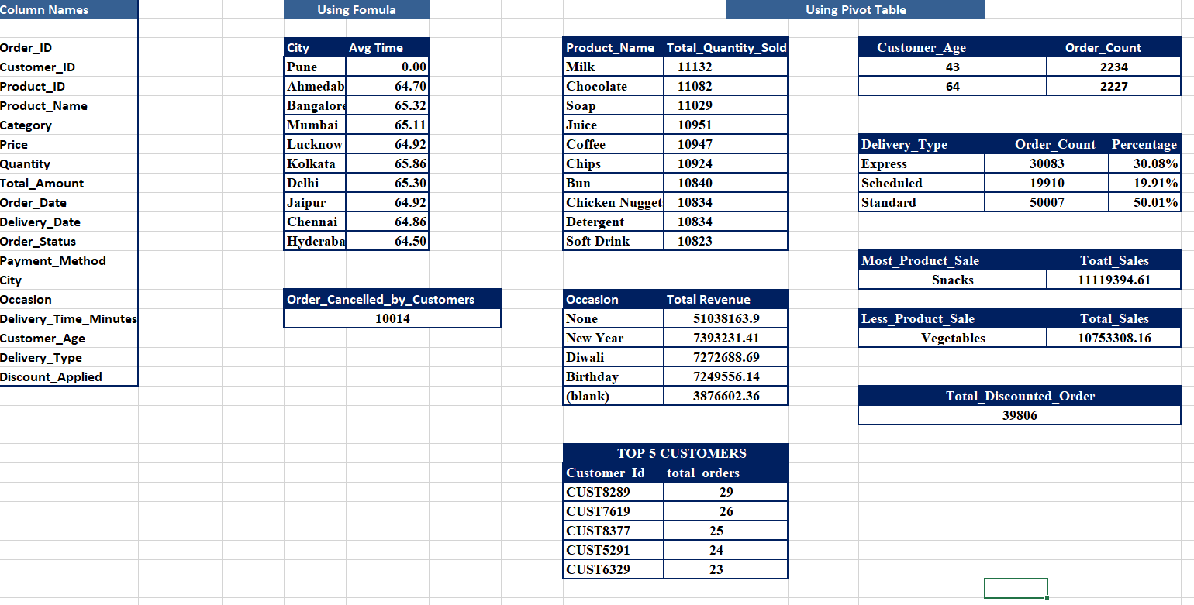

* 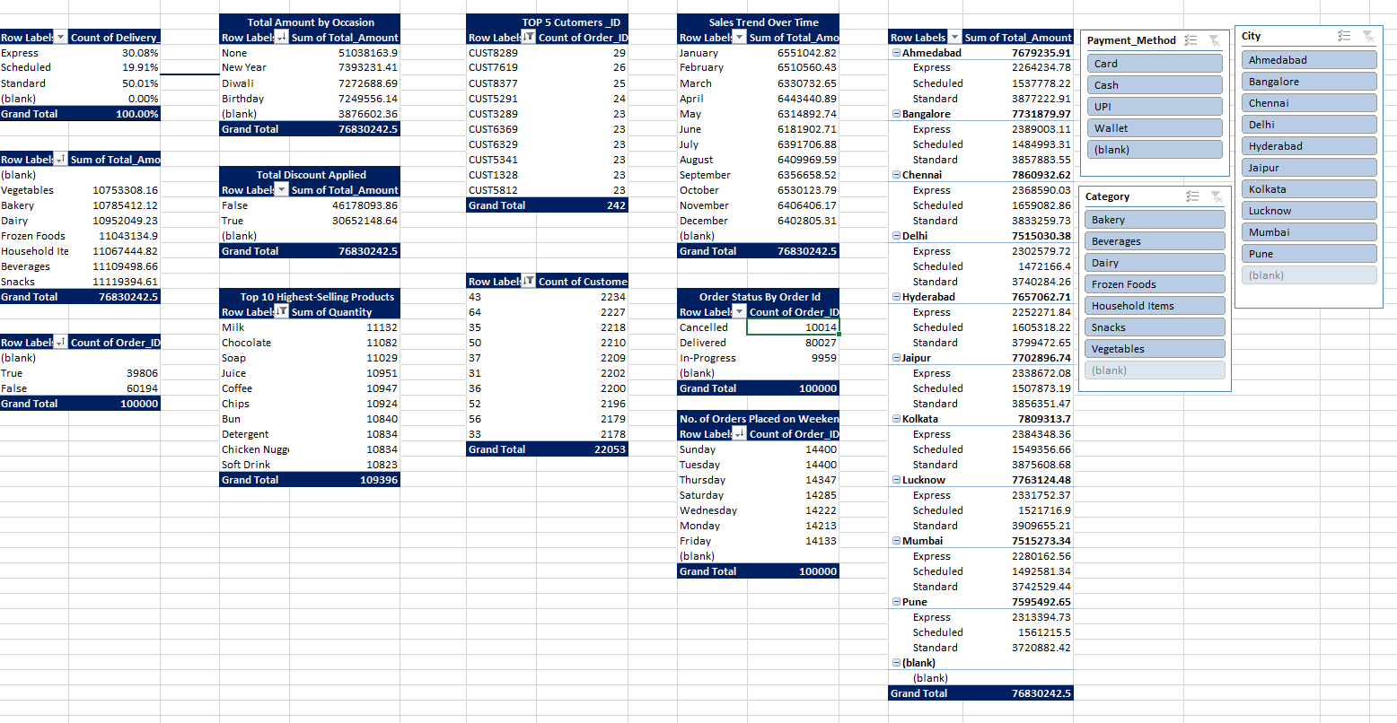**Pivot Table:**
* 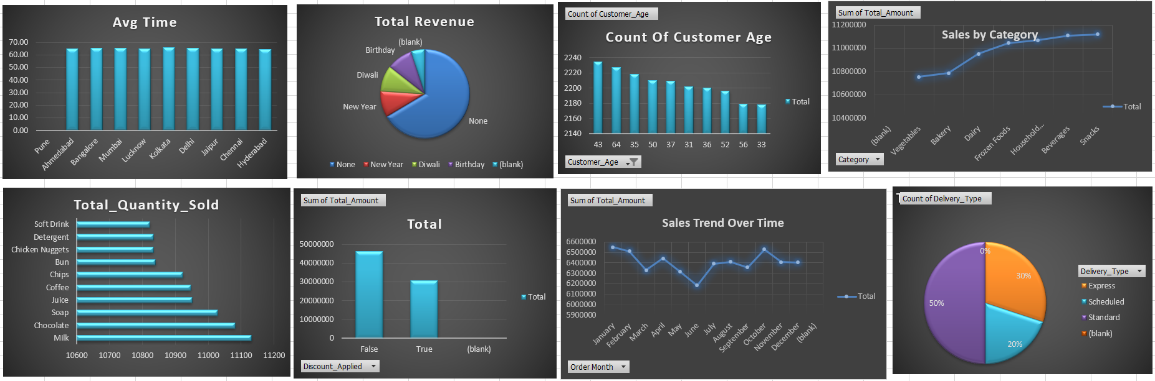**Charts**

**Power BI Questions :**

1. 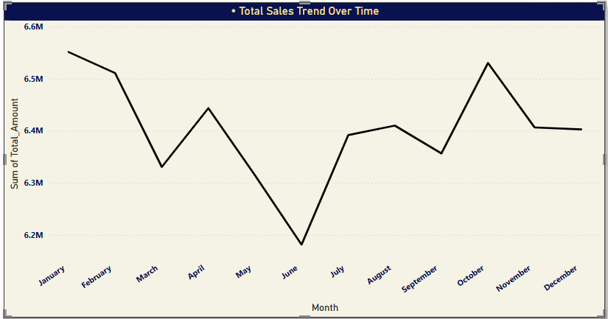**Total Sales Trend Over Time**
2. 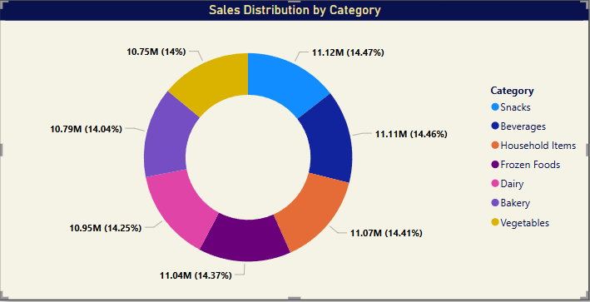**Total Sales Contribution by Category**
3. 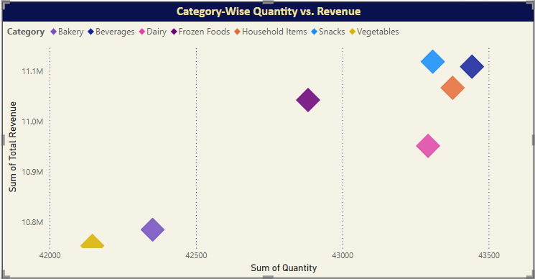**Category wise sales and Revenue**
4. 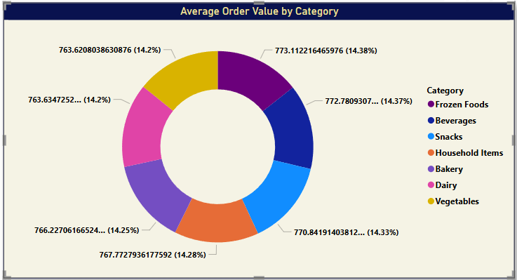**Average order value by Category**
5. 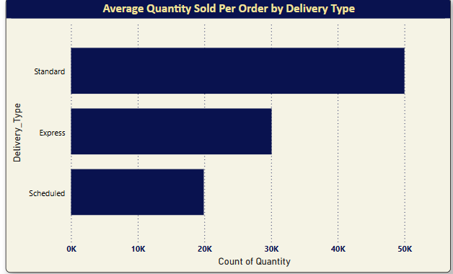**Average quantity sold per order**
6. 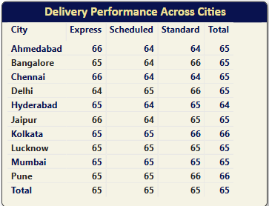**Delivery Type Performance Breakdown**
7. 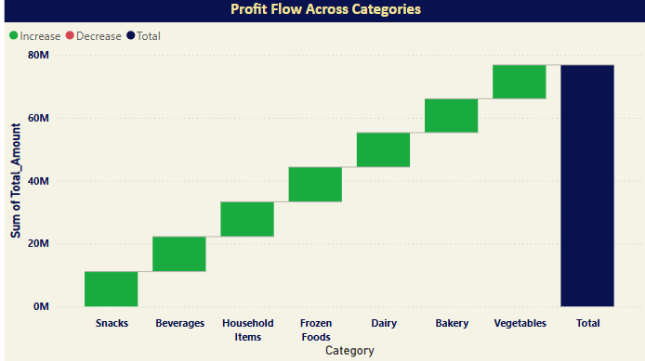**Profit flow across categories**
8. 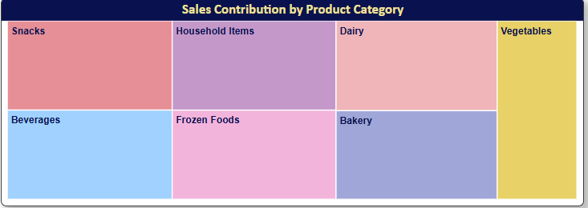**Sales Distribution by product category**
9. 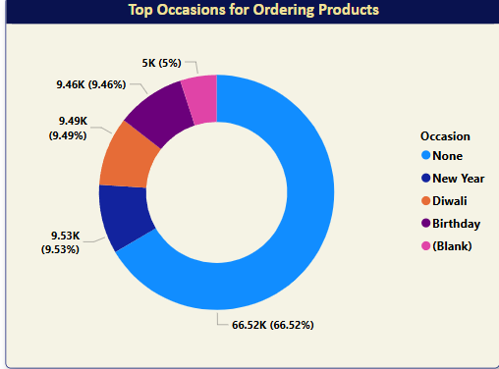**Top occasions for ordering products**
10. 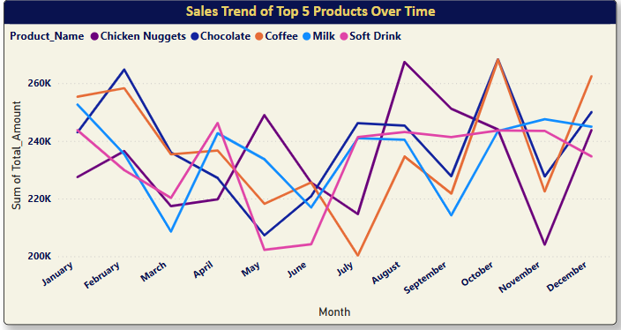**Sales trend of 5 products over time**

* **Segregation of the views:**

**1️⃣ Overview :**

* Total Sales Trend Over Time
* Order Breakdown by Delivery Type
* Total Sales Contribution by Category

**2️⃣ Category Analysis :**

* Top 5 best selling categories
* Category wise sales and Revenue
* Category Sales Trend Over Time
* Average order value by Category

**3️⃣ Delivery Analysis :**

* Average quantity sold per order
* Total sales distribution by Delivery type
* Count of order by Order Status
* Count of order by Delivery_type
* Delivery Type Performance Breakdown

**4️⃣ Sales & Revenue Analysis:**

* Sum of total amount by city
* Profit flow across categories
* Order Distribution by payment method
* Sales Distribution by product category

**5️⃣ Product Performance :**

* Top 5 product by selling product
* Top 10 contribution of product categories
* Top occasions for ordering products
* Sales trend of 5 products over time

**Dashboard:**

